**SEA HORSE MARINE AND TRADING CO**

**TECHNICAL DETAILS – FOR VESSEL MB SEAFARER**

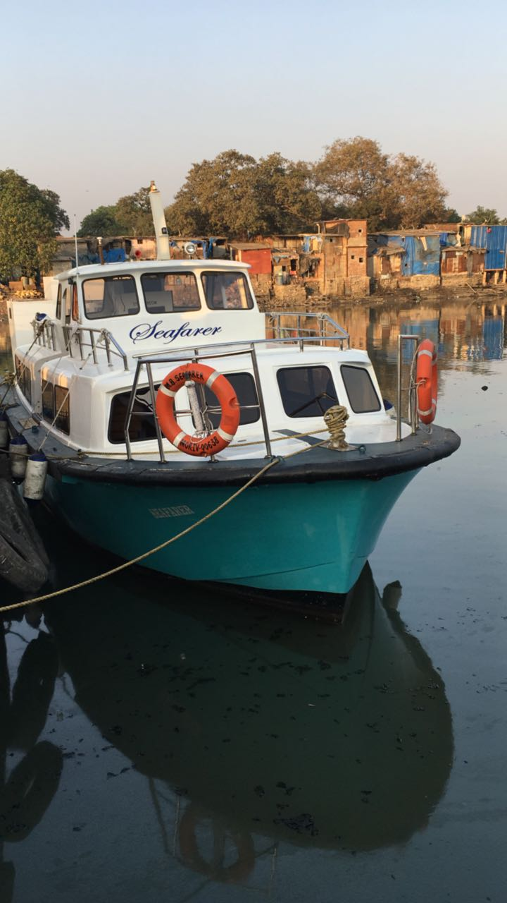

**SPECIFICATIONS**

VESSEL NAME – MB SEAFARER

YEAR OF BUILT – 2016

HULL – FRP

LRNGHT – 14.3 MTRS

BREATH – 5MTRS

DEPTH – 1.5MTRS

FUEL CAPACITY – 500 LTRS TANK

FRESH WATER CAPACITY – 1000 LTRS

MAIN ENGINE – VOLVO PENTA – 160HP X 2 NOS @ 1800 RPM

SPEED :- 10 KNOTS

FUEL CONSUMPTION – 35LTRS BOTH ENGINE P/HR

STEERING SYSTEM: - HYDRUALIC

PASSENGER CAPACITY – 50 PERSONS

**CABIN DETAILS AS FOLLOW**

**1.**FRONT CABIN – IS WITH AC AND CAN ACCOMADATE 20 NOS ON IT

2. BACK CABIN – IS NON AC AND CAN ACCOMADATE – 30 NOS ON IT

**OTHER SALIENT FEATURES**

1. BATHROOM FACILITY ON BOARD THE VESSEL
2. TOILET FACILTY ON BOARD THE VESSEL
3. KITCHEN FOR CREW – WITH ELECTRIC STOVE

THANKS & REGARDS

FOR SEA HORSE MARINE AND TRADING CO

MR SHABIR JABIR FANUSWALA

Email :- [Shabbir@seahorsemarine.in](mailto:Shabbir@seahorsemarine.in)

+91-9892761251